Operating instructions
in keeping with Section 14 of the German Ordinance of Hazardous Substances
Work area:
Workplace:
Field of activity:
Designation of hazardous substances
Cleanet® GR 1
Hazards to man and the environment
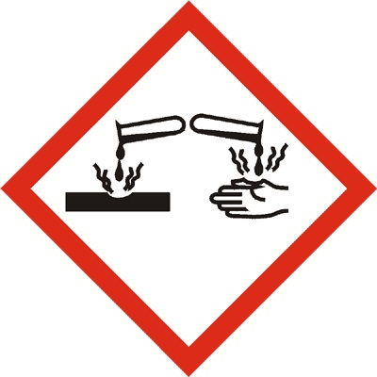 | May be corrosive to metals. Causes severe skin burns and eye damage. Harmful to aquatic organisms, with long-term effects.
Protective measures and rules of conduct
    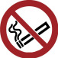 | Ensure very good ventilation of the workplace. Do not smoke, eat or drink in work and storage rooms. Also do not store food, drinks or tobacco. Take care when diluting concentrated alkalis (alkalis, bases) or when mixing with acids - strong heating may occur. Report any malfunction immediately to your supervisor. Carry out repairs properly and with caution. Pipelines must be completely drained. Only decant into clean and lye resistant containers. Only transport fragile containers with the substance using an outer container (e.g. plastic bucket with handle). Only decant into clean and lye resistant containers. Prescribed protective clothing: Safety goggles or face protection, acid and lye resistant gloves, safety shoes, rubber apron and work clothing.
Behaviour in case of danger
In the event of fire-fighting, strictly follow operating instructions.
Extinguish small fires with CO2 or powder extinguisher and/or with a water spray jet. Dilute with plenty of water if possible. Avoid inhalation of dust, vapours or fumes - use breathing apparatus. If leakage of liquid occurs, inform supervisor or plant management immediately.
First aid
 | Provide fresh air, rest and warmth after inhalation. Inform a doctor if necessary. Rinse affected skin with water or dab with a clean cloth and then spray with Diphoterine spray. For larger burns, call an emergency doctor. After swallowing, drink plenty of water, if available with activated carbon additive. Prevent vomiting if possible. If unconscious, bring into stable side position. Consult a physician or seek medical advice. After skin contact, rinse the affected skin immediately with plenty of water. In case of extensive skin wetting, rinse immediately with emergency shower and carefully remove wetted clothing. Then rinse the skin with plenty of water and, if necessary, treat with a detergent such as Diphoterine. Consult a doctor if necessary.
In case of an emergency:

First responder Attending physician
Emergency call
Fire brigade
Proper disposal
 | Absorb spilled liquid with a suitable universal binder and hand over to the responsible body for disposal, as well as waste in closed containers. Small quantities may be diluted with water and discharged into the sewage system. Spilled material should be passed into the waste water treatment plant or absorbed with a suitable universal binder and disposed of after consultation with the plant manager.
Preparation Testing Release
Date
Name
Signature

